Cardiac Resynchronization Therapy Cost In India

Cardiac resynchronization therapy (CRT-D Implantation) cost in India starts from 7000 to 25000 USD depends on quality of Implant. surgeons experience and Hospital services.
The required hospital stay is of 2-3 days and 5 days outside the hospital.
The success rate of Cardiac resynchronization therapy is more than 96%. In severe cases, some risks may arise such as infection at the blooding and abnormal heart rhythms.
Electrocardiogram, Echocardiogram, X-ray and Angiography may be performed to identify heart problems.

When is CRT the right choice?
Patients who qualify for CRT implant are based on studies done in particular subgroups of patients. They typically must satisfy the following:
- Depressed left ventricular ejection fraction < 35%
- Evidence of asynchronous, uncoordinated left and right ventricular contraction with left bundle branch block (LBBB) on 12-lead EKG
- Moderate to severe symptoms of heart failure, despite lifestyle changes and maximal medications

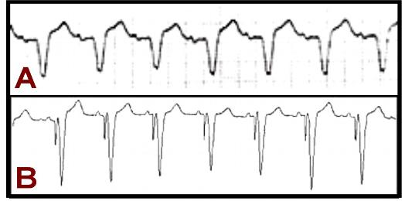
Figure 3. Panel A shows an EKG strip of LBBB in a patient with heart failure and dysynchronous ventricular contraction. With implantation of a CRT system, the patient’s biventricular-paced EKG in Panel B shows narrowing of the QRS-complex with synchronous ventricular contraction.

About two-thirds of patients who undergo CRT implantation report improvement in their symptoms of heart failure. This can be immediate or take weeks as the cardiac muscle remodels. However, still a significant portion of those implanted, that is at least one-third, do not respond to biventricular pacing. Medical management and lifestyle modification is paramount and first-line therapy for congestive heart failure patients.

Types of CRTs

There are two types of CRT devices. One is a special kind of pacemaker. It’s called a cardiac resynchronization therapy pacemaker (CRT-P) or “biventricular pacemaker.” The other is the same device, but it also includes a built-in implantable cardioverter defibrillator (ICD). This type is called a cardiac resynchronization therapy defibrillator (CRT-D).

How CRT-P Devices Work
While functioning like a normal pacemaker to treat slow heart rhythms, a CRT-P device also delivers small electrical impulses to the left and right ventricles to help them contract at the same time so you heart pumps more efficiently.
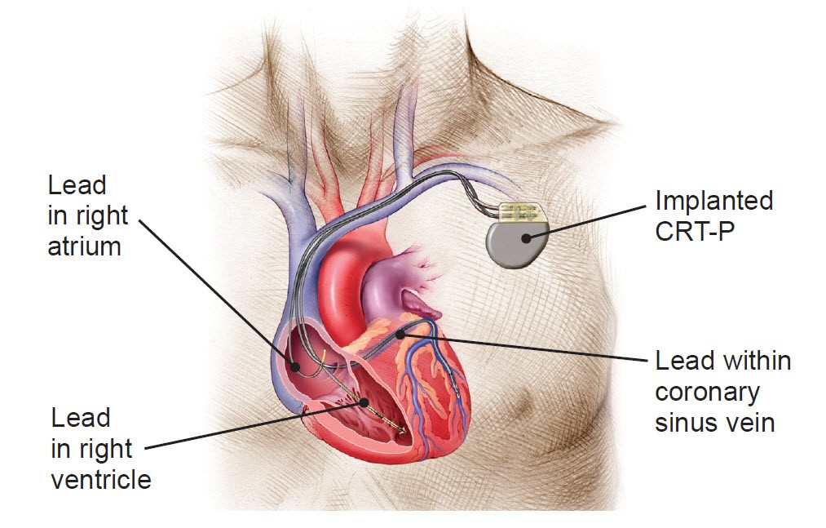

How CRT-D Devices Work
A CRT-D is a special device for heart failure patients who are also at high risk for sudden cardiac death. While functioning like a normal pacemaker to treat slow heart rhythms, a CRT-D device also delivers small electrical impulses to the left and right ventricles to help them contract at the same time. This will help your heart pump more efficiently.
A CRT-D device can also treat dangerously fast heart rhythms (arrhythmias) that can lead to sudden cardiac arrest. If the device senses heartbeats that are dangerously fast, it delivers a shock to the heart. This shock (defibrillation) stops the abnormal rhythm. Without this life-saving therapy, the dangerously rapid rhythm could lead to death in just minutes.
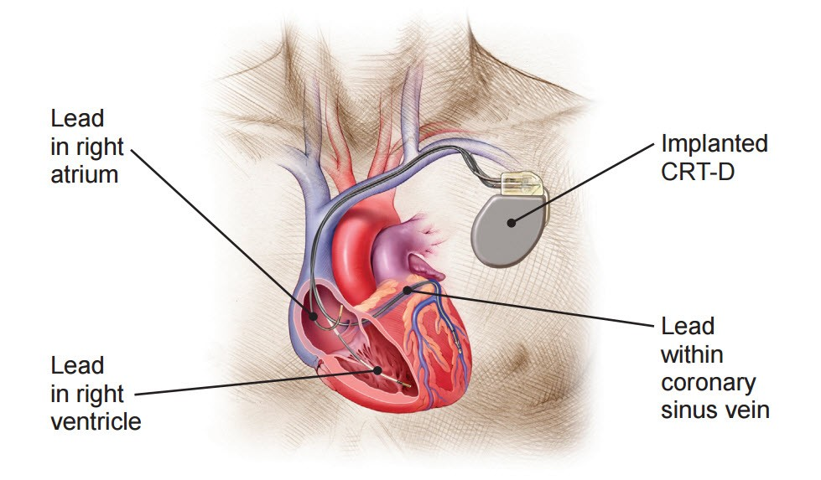

Pre- and Post-Device Implantation Care

Pre-Procedure
- Please arrive at the hospital “fasting” (nothing to eat) from the previous midnight
- You may take your morning medications with a small sip of water
- If you have been instructed to have blood drawn, please do not forget (you may be instructed to have this done several days before your procedure)
- Please make sure you have consulted with your physician if you are on coumadin or insulinfor diabetes. For most procedures, your coumadin will be discontinued or adjusted several days prior.
- If you have not received a phone call from the hospital or our office by the day before the procedure to let you know what time to arrive, please call us.
- Please arrange to have someone drive you to the hospital and home after the procedure as driving is typically limited for at least 1 week after device implantation
- If you develop a cold or are sick, please consult your physician immediately as we may need to postpone your procedure.

The Day of the Procedure
- Please arrive at the prespecified time to allow adequate time for hospital registration and check-in; please call if you will be late.
- Please bring any additional documents your physician has requested.
- Reconfirm with your physician regarding your specific instructions with coumadin and insulin if you have diabetes.
- Please do not wear contact glasses
- If you can avoid, please do not wear or bring jewelry, watches, or money the day of your procedure
- Feel free to bring your own toothbrush, bathrobe, hairbrush, and accessories for your overnight hospital stay
- Your physician will discuss the procedure again with you that morning. Please bring a list of questions if you have any after your office discussion. You will also be asked to sign an informed consent that morning.
- After the procedure, you will have an arm sling for typically 24 hours.
- Expect an overnight hospital stay, with a morning exam to ensure the device and incision site are appropriate.
- Please arrange to have someone drive you to the hospital and home after the procedure as driving is typically limited for at least 1 week after device implantation

Discharge instructions and care
- Your heart rhythm specialist will discuss specific individualized recommendations on your discharge care. The following are general recommendations:
- Once daily dry dressing changes to the incision site. Wash your hands, take off the old dressing, and then cover the incision with a new folded 4X4 gauze and paper-tape. If you have steri-strips, please do not remove them. These steri-strips will be removed at your post-device 1 week followup wound check appointment.
- You may be asked to keep the incision site dry for the week following implantation (you may shower, but need to keep the affected site dry).
- Typically driving is discouraged for at least 1 week or longer after the device is implanted
- Limit heavy lifting with the involved arm for at least 4 weeks
- Extreme motion with the involved arm (above the shoulder) should be avoided for 4-6 weeks after device implantation (this includes activities such as swimming and golf); this could result in lead dislodgement.
- You will need to return to the clinic in 1 week after device implantation to check the healing of the incision site.
- You can return to normal activities within several days
- Speak to your physician regarding your medications after device implantation, including when to resume coumadin.
- Expect 3-5 days of outpatient oral antibiotics after device implantation

Long-term follow-up
- You will need a wound check in 1 week after implantation
- Clinic device and wound surveillance check approximately 6 weeks after implantation
- You will need routine “device clinic” checks with your physician: typically every 4-6 months for a pacemaker system, and every 3-4 months for an ICD. This takes approximately 20 minutes, with the programmer “wand” placed on your chest over your device. A noninvasive review of your device parameters, function, and cardiac events will be printed and kept with your records.
- Always carry your device identification card. You will be given a temporary card on discharge from the hospital, with mailing of the permanent within 6-8 weeks thereafter.
- An intensified monitoring period will be instituted as battery depletion is detected. This is determined during your routine device checks as residual battery level can be projected. “Device clinic” checks will change to every 2-3 months or less thereafter.
- Replacement of the pacemaker or ICD generator is performed during the “elective replacement interval” determined by the device’s battery life. Expect a 5 to 8 year average generator life for a pacemaker and a 3 to 6 year life-span for a defibrillator system.

Misconceptions
- Your device has built-in features to protect it from the electrical interference produced by most household electrical appliances. Generally microwave ovens, computers, VCRs, and garage door openers are all safe to use.
- Airport walk-through metal detectors are safe, but you may set the alarm off. Always have your device identification card on hand, and have them perform a hand search instead.

Precautions
- Be wary of contact sports
- Avoid placing your cellular phone directly over your device generator. Try to keep it at least 6 inches away from your device. Do not carry your cellular phone in your shirt pocket when not in use.
- Magnetic resonance imaging (MRI) scans should be avoided unless your physician deems otherwise
- Avoid prolonged exposure in the vicinity to electronic security systems (anti-theft devices), including metal-detector “wands” and those located at the entrance of department stores.
- Your device is sensitive to strong electromagnetic interference (EMI) generated by certain electric or magnetic fields of sufficient strength. Hence, avoid working near heavy or high-voltage machinery (running motors and alternators), exposure to arc-welding equipment, CB radio antennas, and MRI scans.

Frequently Asked Questions Related to Crt D Implant Cardiac Resynchronization Therapy

What is a CRT-D implant?

A CRT-D is an implantable cardiac resynchronization therapy (CRT) defibrillator for patients with heart failure which monitor heart's rhythm, detects irregularities and corrects them with electrical impulses.

What does CRT-D stand for?
It's called a cardiac resynchronization therapy pacemaker (CRT-P) or “biventricular pacemaker.” The other is the same device, but it also includes a built-in implantable cardioverter defibrillator (ICD). This type is called a cardiac resynchronization therapy defibrillator (CRT-D).

Is CRT-D Safe?
Yes, CRT-D is very safe procedure. The devices being used for the procedure is being approved by FDA.

What types of CRT devices are there?
Usually there are two types of CRT device one is called CRT-P ( cardiac resynchronization therapy pacemaker) and the other is same device but it also includes built-in implantable cardioverter defibrillator.

What does a CRT-D device do?
CRT-D device is a special device for heart failure patients who are also at high risk for sudden cardiac death. CRT-D devices treats the fast rhytms of heart which can result in sudden cardiac arrest. If the device which are sensing the heartbeats are very fast then it will deliver a shock to heart, that shock will stop the abnormal rhythm of heart.

What are the benefits of a CRT device?
Heart failure is a chronic and progressive disease the early use of CRT therapy will help you in keeping alive for longer time. If you are having any symptoms the CRT device has the ability to improve your health which in turn will improve your life also. CRT device does not totally cure the heart failure but many patients who have received CRT will feel better and get relief from symptoms and they will get more energy in participating in daily activities.

How long can you live with a CRT-D?
The median survival after device implantation is 4.62 years for CRT-P and 5.15 years for CRT-D.

What is CRT-D placement?
In this procedure the surgeon will insert three leads into the major vein near your collarbone and by using x ray the surgeon will guide the leads through the veins and then place them into the upper and lower chamber of heart. At last, CRT-D is being implanted by making an incision below the skin.

What is CRT-D in heart failure?
CRT-D is a special device which is used for treating high risk of getting death due to cardiac disease. This device functions like normal pacemaker for treating the heart rhythms. This device also delivers small electrical impulses to the left and right ventricles and also helps them to contract simultaneously.

Is a CRT a pacemaker?
CRT is a treatment which is being done for make your heart beat in right rhythm this device uses a pacemaker which restores the normal timing pattern of heartbeat. This pacemaker coordinates with the timings of both upper and lower heart chambers.

Who needs to undergo CRT-D placement procedure?
You can go for CRT-D placement if your LVEF≤ 35% or moderate to severe if it is seen on any latest echocardiogram or any contrast ventriculogram or MRI.

